PROJECT SCHEDULE
Project Title: |  | Date Prepared:
Sample Gantt Chart
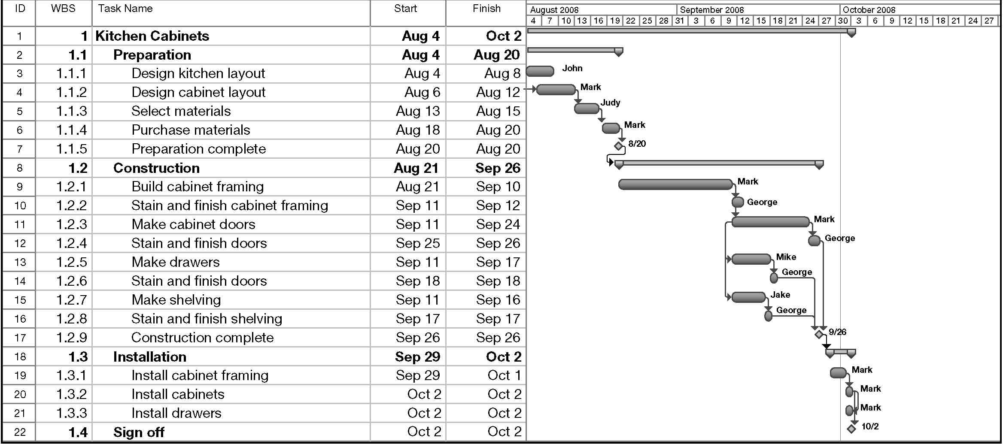

PROJECT SCHEDULE
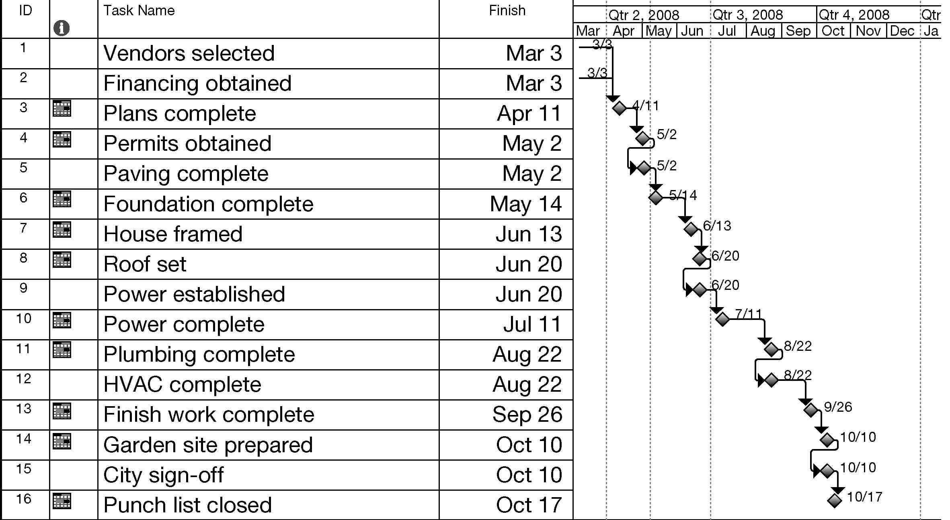
Sample Milestone Chart

