PROJECT MANAGEMENT PLAN

Project title: Date Prepared:

Project life cycle:

Phase | key activities | key Deliverables

Phase | reviews | entry criteria | exit criteria

Development approaches:

Deliverable | Development approach

Subsidiary Management Plans:

name | comment
Scope
Time
Cost
Quality
Resource
Communications
Risk
Procurement
Stakeholder
Other Plans
Page 1 of 2
PROJECT MANAGEMENT PLAN

variance thresholds:

Scope variance threshold | Scope baseline Management
Schedule variance threshold | Schedule baseline Management
cost variance threshold | cost baseline Management

baselines:

Attach all project baselines.

Page 2 of 2

CHANGE MANAGEMENT PLAN

Project title: Date Prepared:

change Management approach:

Definitions of change:

Schedule change:
Budget change:
Scope change:
Project document changes:

change control board:

name | role | responsibility | authority

change control Process:

Change request submittal
Change request tracking
Change request review
Change request disposition

Attach relevant forms used in the change control process.

Page 1 of 1

Approach
Waterfall phases.
PROJECT ROADMAP
Iterative development of content throughout Development, QC Edit, Exposure, and Finalization Phases.

Life Cycle Phases

Origination

Timeline

Project Origination Review
Sep 2

SME/MAG Review

Development

Standard
Finalized

QC and Edit

Exposure

Exposure Draft posted
Mar 14

Finalize

Consensus Body
Approval
3rd Quarter
Nov 12
1st Quarter 3rd Quarter 1st Quarter 3rd Quarter
Dec 11

Start
Jun 2 '14

Project Start Up
Jun 2 - Sep 2

Project Standard
Sep 2 '14 - Dec 27 '14

Exposure Jan 14 – Feb 13

Adjudicate and Appeals
Feb 14 – June 13

Knowledge Areasa
Dec 27 - Oct 28a

Guide QC and Edit
Nov 1 – Mar 1
Guide Exposure Draft
Mar 1 – Aug 1
QC and Finalize
Aug 1 – Oct 1

Front End Chapters 1-4a
Sep 2 - Mar 23a

Front End baselined
Mar 23

SME/MAG Review
Dec 27

SME/MAG Review
Jun 27a

Pre-Exposure Draft Vote
Oct 28

Exposure Complete Aug 1

Contingency
Oct 1 - Dec
31

QC Review
Sept 7

Project Target End Date
Dec 31 '16

Page 1 of 1
SCOPE MANAGEMENT PLAN

Project title: Date:

Work breakdown (WbS) Structure

WbS Dictionary

Scope baseline Maintenance

Deliverable acceptance

Scope and requirements integration

Page 1 of 1
REQUIREMENTS MANAGEMENT PLAN

Project title: Date:

collection:

analysis:

categories:

Documentation:

Prioritization:

Page 1 of 2
REQUIREMENTS MANAGEMENT PLAN

Metrics:

traceability Structure:

tracking:

reporting:

validation:

configuration Management:

Page 2 of 2
REQUIREMENTS DOCUMENTATION

Projecttitle: DatePrepared:

iD | requirement | Stakeholder | category | Priority | acceptance criteria | testor verification | Phaseor release

Page1of1
REQUIREMENTS TRACEABILITY MATRIX

Projecttitle: DatePrepared:

requirement information |  |  |  |  | relationship traceability
iD | requirement | Source | Priority | category | business objective | Deliverable | verification | validation

Page1of2
INTER-REQUIREMENTS TRACEABILITY MATRIX

Project title: Date Prepared:

iD | business requirement | Priority | Source | iD | technical requirement | Priority | Source

Page 2 of 2
PROJECT SCOPE STATEMENT

Project title: Date Prepared:

Project Scope Description:

Project Deliverables:

Product acceptance criteria:

Project exclusions:

Page 1 of 2
PROJECT SCOPE STATEMENT

Project constraints

Project assumptions

Page 2 of 2
WORK BREAKDOWN STRUCTURE

Project title: Date Prepared:

1. Project
1.1. Major Deliverable
1.1.1. Control Account
1.1.1.1. Work Package
1.1.1.2. Work Package
1.1.1.3. Work Package
1.1.2. Work Package
1.2. Control Account
1.2.1. Work Package
1.2.2. Work Package
1.3. Major Deliverable
1.3.1. Control Account

1.3.1.1. Work Package
1.3.1.2. Work Package
1.3.1.3. Work Package
1.3.2. Control Account
1.3.2.1. Work Package
1.3.2.2. Work Package

Page 1 of 1
WBS DICTIONARY

Project title: Date Prepared:

Work Package name: |  |  | code of accounts:
Description of Work: |  |  | assumptions and constraints:
Milestones:  1.  2.  3. |  |  | Due Dates:
iD | activity | resource | labor |  |  | Material |  |  | total cost
 |  |  | hours | rate | total | units | cost | total
quality requirements:
acceptance criteria:
technical information:
agreement information:

Page 1 of 1
SCHEDULE MANAGEMENT PLAN

Project title: Date:

Schedule Methodology:

Scheduling tools:

level of accuracy: units of Measure: variance thresholds:

Schedule reporting and Format:

organizational Procedure links:

Schedule updates:

Page 1 of 1
ACTIVITY LIST

Project title: Date Prepared:

iD | activity | Description of Work

Page 1 of 1
62 Planning Forms
ork.
ACTIVITY ATTRIBUTES

Project title: Date Prepared:

iD: | activity:
Description of Work:
Predecessors | relationship | lead or lag | Successor |  | relationship | lead or lag
number and type of team resources required: |  | Skill requirements: |  | required resources:
type of effort:
location of Performance:
imposed Dates or other constraints:
assumptions:

Page 1 of 1

MILESTONE LIST

Project title: Date Prepared:

Milestone | Milestone Description | type

Page 1 of 1
NETWORK DIAGRAM

Project Title: Date Prepared:

B +2d D

Start A G
FF

FS-2d

C E
SS

H I End

F

In this network diagram:
There is a two-day lead between the completion of A and beginning of C. There is a two-day lag between the completion of B and beginning of D. There is a start-to-start relationship between E and F.
There is a nish-to- nish relationship between G and H. All other relationships are nish-to-start.

Page 1 of 1
DURATION ESTIMATES

Project title: Date Prepared:

iD | activity Description | effort hours | Duration estimate

Page 1 of 1
DURATION ESTIMATING WORKSHEET

Project title: Date Prepared:

Parametric estimates
ID | Effort Hours | Resource  Quantity | % Available | Performance  Factor | Duration  Estimate
analogous estimates
ID | Previous  Activity | Previous  Duration | Current Activity | Multiplier | Duration  Estimate
three-Point estimates
ID | Optimistic  Duration | Most Likely  Duration | Pessimistic  Duration | Weighting  Equation | Expected Duration Estimate

Page 1 of 1
PROJECT SCHEDULE

SampleGanttChart

ID WBS TaskName Start Finish
August2008 September2008 October2008
4 7 10 13 16 19 22 25 28 31 3 6 9 12 15 18 21 24 27 30 3 6 9 12 15 18 21 24 27
1 1 KitchenCabinets Aug4

2 1.1 Preparation Aug4
3 1.1.1 Designkitchenlayout Aug4

4 1.1.2 Designcabinetlayout Aug6

5 1.1.3 Selectmaterials Aug13

6 1.1.4 Purchasematerials Aug18

7 1.1.5 Preparationcomplete Aug20

8 1.2 Construction Aug21
9 | 1.2.1 | Buildcabinetframing | Aug21 | Sep10
10 | 1.2.2 | Stainand nishcabinetframing | Sep11 | Sep12
11 | 1.2.3 | Makecabinetdoors | Sep11 | Sep24
12 | 1.2.4 | Stainand nishdoors | Sep25 | Sep26
13 | 1.2.5 | Makedoors | Sep11 | Sep17
14 | 1.2.6 | Stainand nishdrawers | Sep18 | Sep18
15 | 1.2.7 | Makeshelving | Sep11 | Sep16
16 | 1.2.8 | Stainand nishshelving | Sep17 | Sep17
17 | 1.2.9 | Constructioncomplete | Sep26 | Sep26
18 | 1.3 | Installation | Sep29 | Oct2
19 | 1.3.1 | Installcabinetframing | Sep29 | Oct1
20 | 1.3.2 | Installcabinets | Oct2 | Oct2
21 | 1.3.3 | Installdrawers | Oct2 | Oct2
22 | 1.4 | Signoff | Oct2 | Oct2

Oct2

Aug20
Aug8

Aug12

Aug15

Aug20

Aug20

Sep26

John

Mark

Judy

Mark

8/20

Mark

George

Mark

George
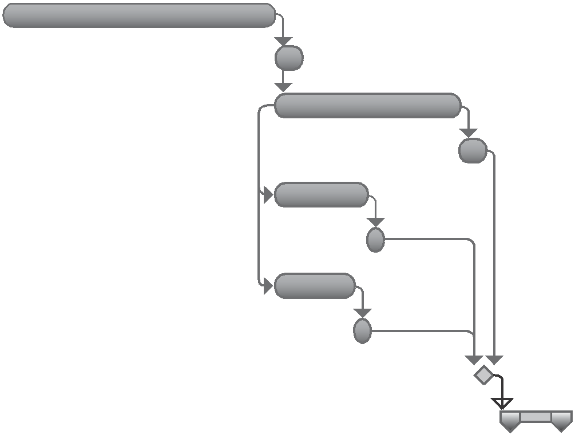
Mike
George

Jake

George

9/26

Mark Mark Mark
10/2

Page1of2
PROJECT SCHEDULE

Sample Milestone Chart

ID Task Name Finish Qtr 2, 2008
Qtr 3, 2008 Qtr 4, 2008 Qtr

1 Vendors selected
2 Financing obtained

Mar 3
Mar 3
Mar Apr
3/3

3/3
May Jun Jul Aug Sep Oct Nov Dec Ja
3 Plans complete
4 Permits obtained
5 Paving complete
6

7

8

9

10

11

12

13

14

15

16
Apr 11
May 2
May 2
Foundation complete | May | 14
House framed | Jun | 13
Roof set | Jun | 20
Power established | Jun | 20
Power complete | Jul | 11
Plumbing complete | Aug | 22
HVAC complete | Aug | 22
Finish work complete | Sep | 26
Garden site prepared | Oct | 10
City sign-off | Oct | 10
Punch list closed | Oct | 17

4/11

5/2

5/2

5/14

6/13

6/20

6/20

7/11

8/22

8/22

9/26

10/10

10/10

10/17
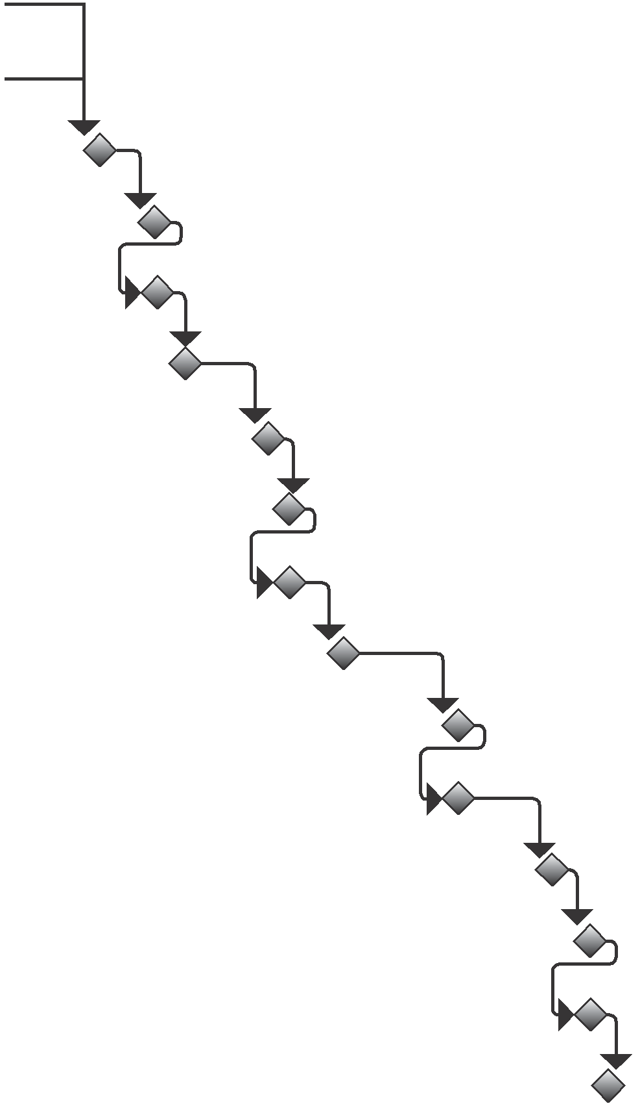

Page 2 of 2
COST MANAGEMENT PLAN

Project title: Date Prepared:

units of Measure: | level of Precision: | level of accuracy:

organizational Procedure links:

control thresholds:

rules of Performance Measurement:

cost reporting and Format:

additional Details:

Page 1 of 1
ACTIVITY COST ESTIMATES

Project Title: Date Prepared:

WBS  ID | Resource | Labor  Costs | Physical  Costs | Reserve | Estimate | Method | Assumptions/  Constraints | Basis of Estimates | Range | Con dence  Level

Page 1 of 1
COST ESTIMATING WORKSHEET

Project title: Date Prepared:

Parametric estimates
iD | cost variable | cost per unit | number of units | cost estimate
analogous estimates
iD | Previous activity | Previous cost | current activity | Multiplier | cost estimate
three-Point estimates
iD | optimistic cost | Most likely cost | Pessimistic cost | Weighting equation | expected cost estimate

Page 1 of 2
BOTTOM-UP COST ESTIMATING WORKSHEET

Project title: Date Prepared:

iD | labor hours | labor rate | total labor | Material | Supplies | equipment | travel | other Direct costs | indirect costs | reserve | estimate

Page 2 of 2
COST BASELINE

Project Title:

14,000

12,000

10,000

8,000

6,000

4,000

2,000
Date Prepared:

0
1 2 3 4 5 6 7

Page 1 of 1
QUALITY MANAGEMENT PLAN

Project title: Date Prepared:

quality Standards

quality objectives

Metric or Specification | Measure
1. | 1.
2. | 2.
3. | 3.
4. | 4.

quality roles and responsibilities

roles | responsibilities
1. | 1.
2. | 2.
3. | 3.

Page 1 of 2
QUALITY MANAGEMENT PLAN

Deliverables and Processes Subject to quality review

Deliverables | Processes

quality Management approach

quality control approach

applicable quality Procedures

Page 2 of 2

QUALITY METRICS

Project title: Date Prepared:

iD | item | Metric | Measurement Method

Page 1 o
RESPONSIBILITY ASSIGNMENT MATRIX

Project title: Date Prepared:

 | Person 1 | Person 2 | Person 3 | Person 4 | etc.
Work package 1 | r | c | a
Work package 2 |  | a |  | i | r
Work package 3 |  | r | r | a
Work package 4 | a | r | i | c
Work package 5 | c | r | r |  | a
Work package 6 | r |  | a | i
Etc. | c | a |  | r | r

r = Responsible: The person performing the work.

c = Consult: The person who has information necessary to complete the work.

a = Accountable: The person who is answerable to the project manager that the work is done on time, meets requirements, and is acceptable.

i = Inform: This person should be noti ed when the work is complete.

Page 1 of 1
104 Planning Forms

RESOURCE MANAGEMENT PLAN

Project title: Date Prepared:

team Member identification and estimates

role | number | Skill level
1.  2.  3.  4.  5.  6. | 1.  2.  3.  4.  5.  6. | 1.  2.  3.  4.  5.  6.

Staff acquisition Staff release:

roles, responsibilities, and authority

role | responsibility | authority
1.  2.  3.  4.  5.  6. | 1.  2.  3.  4.  5.  6. | 1.  2.  3.  4.  5.  6.

Project organizational Structure

RESOURCE MANAGEMENT PLAN

training requirements

rewards and recognition

team Development

Physical resource identification and estimates

resource | amount | grade
1.  2.  3.  4.  5.  6. | 1.  2.  3.  4.  5.  6. | 1.  2.  3.  4.  5.  6.

resource acquisition

resource Management

Page 2 of 2
TEAM CHARTER

Project title: Date Prepared:

team values and Principles:

1.

2.

3.

4.

5.

Meeting guidelines:

1.

2.

3.

4.

5.

communication guidelines:

1.

2.

3.

4.

5.

Decision-Making Process:

Page 1 of 2
TEAM CHARTER

conflict resolution Process:

other agreements:

Signature: Date:

Page 2 of 2
RESOURCE REQUIREMENTS

Project title: Date Prepared:

iD | resource | quantity | assumptions | comments

Page 1 of 1
RESOURCE BREAKDOWN STRUCTURE

Project title: Date Prepared:

1. Project

1.1. People

1.1.1. Quantity of Role 1

1.1.1.1. Quantity of Level 1

1.1.1.2. Quantity of Level 2

1.1.1.3. Quantity of Level 3

1.1.2. Quantity of Role 2

1.2. Equipment

1.2.1. Quantity of Type 1

1.2.2. Quantity of Type 2

1.3. Materials

1.3.1. Quantity of Material 1

1.3.1.1. Quantity of Grade 1

1.3.1.2. Quantity of Grade 2

1.4. Supplies

1.4.1. Quantity of Supply 1

1.4.2. Quantity of Supply 2

1.5. Locations

1.5.1. Location 1

1.5.2. Location 2

Page 1 of 1
COMMUNICATIONS MANAGEMENT PLAN

Project title: Date Prepared:

Stakeholder | information | Method | timing or Frequency | Sender

assumptions | constraints

glossary of terms or acronyms:

attach relevant communication diagrams or flowcharts.

Page 1 of 1
RISK MANAGEMENT PLAN

Project title: Date Prepared:

Strategy

Methodology

roles and responsibilities

role | responsibility
1.  2.  3.  4. | 1.  2.  3.  4.

risk categories

risk Management Funding

contingency Protocols

Page 1 of 4
RISK MANAGEMENT PLAN

Project title: Date Prepared:

Frequency and timing

Stakeholder risk tolerances

risk tracking and audit

Page 2 of 4
RISK MANAGEMENT PLAN

Definitions of Probability

very high
high
Medium
low
very low

Definitions of impact by objective

 | Scope | quality | time | cost
very high
high
Medium
low
very low

Page 3 of 4
RISK MANAGEMENT PLAN

Probability and impact Matrix

very high
high
Medium
low
very low
 | very low | low | Medium | high | very high

Page 4 of 4
RISK REGISTER

Project title: Date Prepared:

iD | risk Statement | owner | Probability | impact |  |  |  | Score | response
 |  |  |  | Scope | quality | Schedule | cost

revised  Probability | impact |  |  |  | revised  Score | responsible  Party | actions | Status | comments
 | Scope | quality | Schedule | cost

Page 1 of 1
RISK REPORT

Project title: Date:

executive Summary

overall Project riSk

overall risk Status and trends

Significant Drivers of overall risk recommended responses

inDiviDual Project riSkS

indicate the number of individual risks in each box below.

VH
H
M
L
VL
 | VL | L | M | H | VH

Page 1 of 4
RISK REPORT

Metrics

Number of scope risks
Number of schedule risks
Number of cost risks
Number of quality risks
Number of very high probability risks
Number of high probability risks
Number of medium probability risks
Number of active risks
Newly closed risks

critical risks

Top Risks | Responses
1. | 1.
2. | 2.
3. | 3.
4. | 4.
5. | 5.

changes to critical risks

Page 2 of 4
RISK REPORT

quantitative analysis Summary

Probability of Meeting objectives:

Scope | Schedule | Cost | Quality | Other

range of outcomes

Range of Schedule Outcomes | Range of Cost Outcomes

Key Drivers of Variances | Proposed Responses

reserve Status

Total Cost Reserve | Used to Date | Used This Period | Remaining Reserve

Total Schedule Reserve | Used to Date | Used This Period | Remaining Reserve
Page 3 of 4
RISK REPORT

assessment of reserve adequacy

risk audit Summary

Summary of Risk Events
Summary of Risk Management Processes
Summary of Recommendations

Page 4 of 4
PROBABILITY AND IMPACT RISK RATING
Project title: Date Prepared: Scope impact

Very High
High
Medium
Low
Very Low

quality impact

Very High
High
Medium
Low
Very Low

Schedule impact

Very High
High
Medium
Low
Very Low

Page 1 of 2
PROBABILITY AND IMPACT RISK RATING

cost impact

Very High
High
Medium
Low
Very Low

Probability

Very High
High
Medium
Low
Very Low

risk rating

High
Medium
Low

Page 2 of 2
PROBABILITY AND IMPACT MATRIX

Project Title: Date Prepared:
Very Low
Low
Medium
High
Very High

Very Low Low Medium High Very High

Page 1 of 1
RISK DATA SHEET

Project title: Date Prepared:

risk iD: | risk Description:
Status: | risk cause:
Probability | impact |  |  |  | Score |  | responses
 | Scope | quality | Schedule | cost
revised  Probability | revised impact |  |  |  | revised  Score |  | responsible  Party | actions
 | Scope | quality | Schedule | cost
Secondary risks:
residual risk:
contingency Plan: |  |  |  |  |  | contingency Funds:
 |  |  |  |  |  | contingency time:
Fallback Plans:
comments:

Page 1 of 1
that will be used.PROCUREMENT MANAGEMENT PLAN

Project title: Date:

Procurement integration

area | integration approach
Scope
Schedule
Documentation
Risk
Reporting

timing of key Procurement activities

Date | activity

Performance Metrics

item | Metric | Measurement Method

Page 1 of 2
PROCUREMENT MANAGEMENT PLAN

roles, responsibility, and authority

role | responsibility | authority

assumptions and constraints

category | assumption/constraint

legal jurisdiction and currency

independent estimates

risk Management

Prequalified Sellers

1.
2.
3.
4.

Page 2 of 2
PROCUREMENT STRATEGY

Project title: Date:

Delivery Method

contract type

FFP FPIF FP-EPA CPFF CPIF CPAF T&M Other

incentive or award Fee | criteria

Procurement life cycle

Phase | entry criteria | key Deliverables or Milestones | exit criteria | knowledge transfer

Page 1 of 1
SOURCE SELECTION CRITERIA

Project title: Date Prepared:

 | 1 | 2 | 3 | 4 | 5
criterion 1
criterion 2
criterion 3
criterion 4
criterion 5

 | Weight | candidate 1 rating | candidate 1  Score | candidate 2 rating | candidate 2  Score | candidate 3 rating | candidate 3  Score
criterion 1
criterion 2
criterion 3
criterion 4
criterion 5
totals

Page 1 of 1
STAKEHOLDER ENGAGEMENT PLAN

Project title: Date Prepared:

Stakeholder | unaware | resistant | neutral | Supportive | leading

C = Current level of engagement D = Desired level of engagement

Pending Stakeholder changes

Stakeholder relationships

Page 1 of 2
STAKEHOLDER ENGAGEMENT PLAN

Stakeholder engagement approach

Stakeholder | approach

Page 2 of 2

